Chapter 13, Problem 26.

Find I_{o} in the circuit of Fig. 13.95. Switch the dot on the winding on the right and calculate I_{o} again.

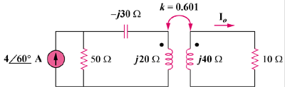

Figure 13.95
For Prob. 13.26.

